
DEPARTMENT OF CSE
Deep Learning Framework for Automated Pneumonia Detection Using Chest X-ray Images

Course Name: Applied Machine Learning In Text Analysis
Course Code: 24ALT3101
Team Members: Allam Greshmica (2420030017)
Mikkineni Thanvitha (2420030040)

Abstract:
Pneumonia is one of the leading causes of death worldwide and requires early diagnosis for effective treatment. Chest X-ray imaging is the most widely used diagnostic technique; however, manual interpretation by radiologists is time-consuming and prone to errors, particularly in hospitals with limited medical resources. This project proposes an Explainable Deep Learning Framework for Automated Pneumonia Detection Using Chest X-ray Images by integrating Convolutional Neural Networks (CNN), DenseNet-121, EfficientNet, Transformer models, and Bidirectional Encoder Representations from Transformers (BERT) to improve diagnostic accuracy and interpretability. The proposed framework utilizes multiple publicly available Chest X-ray datasets to improve model robustness and generalization across diverse patient populations. The system performs image preprocessing, augmentation, feature extraction, deep learning-based classification, and prediction through a comprehensive AI pipeline. DenseNet and EfficientNet are employed for extracting high-level visual features, while Transformer architectures enhance feature representation and contextual understanding. Explainable AI techniques such as Grad-CAM are incorporated to highlight infected lung regions, enabling clinicians to understand the reasoning behind model predictions. Furthermore, BERT combined with a Large Language Model (LLM) generates simplified diagnostic summaries and clinical explanations based on the predicted results, making the system more accessible to healthcare professionals and patients. A complete web-based application consisting of a React frontend and FastAPI backend is developed to provide real-time image upload, pneumonia prediction, confidence scores, heatmap visualization, AI-generated medical reports, and patient history management. The proposed framework is evaluated using Accuracy, Precision, Recall, F1-Score, ROC-AUC, and Confusion Matrix to ensure reliable performance. The developed system aims to support hospitals and healthcare professionals by providing an accurate, scalable, explainable, and AI-assisted pneumonia detection solution.

Problem Statement:
Pneumonia is a serious infection of the lungs that can cause breathing problems and other health complications if it is not detected early. Chest X-rays are commonly used to detect pneumonia, but doctors need to examine these X-rays manually, which can take time. The diagnosis can also be affected by human error and differences in doctors’ experience. In hospitals with fewer experienced radiologists, this can be an even bigger challenge.
AI can help detect pneumonia from chest X-rays quickly, but some AI models only give a result such as “Pneumonia” or “Normal” without explaining why. Therefore, we need a system that can not only detect pneumonia accurately and quickly, but also show the areas of the X-ray that influenced its decision. This makes the AI prediction easier to understand and more trustworthy for doctors.
Objectives:
To develop an explainable and robust deep learning framework for automated pneumonia detection from chest X-ray images by addressing the limitations identified in existing research.
1. Improve Generalisation: Use multiple chest X-ray datasets to improve model robustness and generalisation.
2. Improve Classification: Compare CNN, DenseNet-121, EfficientNet and Transformer models for accurate pneumonia detection.
3. Provide Explainability: Use Grad-CAM to highlight lung regions influencing the model's prediction.
4. Generate Understandable Explanations: Combine Grad-CAM with BERT + LLM to provide visual and textual explanations.
5. Ensure Reliable Evaluation: Evaluate the model using Accuracy, Precision, Recall, F1-score, ROC AUC and Confusion Matrix.
6. Develop an End-to-End System: Integrate the model into a React + FastAPI application for X-ray upload, prediction, visualization and AI-assisted reporting.

Literature Review:
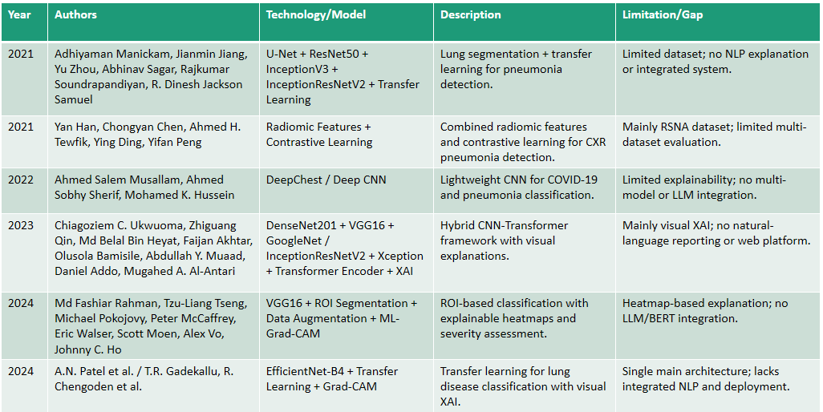
Research Gap Identification:
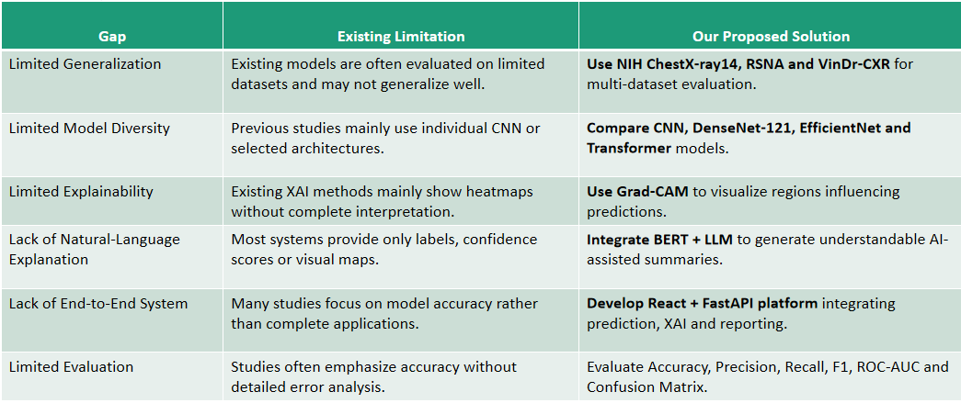
Innovation:
- Multi-Dataset Learning: Uses NIH ChestX-ray14, RSNA and VinDr-CXR for broader evaluation.
- Hybrid Deep Learning: Combines CNN, DenseNet-121, EffecientNet and Transformer models.
- Explainable AI: Uses Grad-CAM to highlight pneumonia-related regions in X-rays.
- AI-Assisted Explanation: Combines model results with BERT + LLM for understandable summaries.
- End-to-End Platform: Integrates Prediction, explanation and reporting through React + FastAPI.
- Comprehensive Evaluation: Uses multiple performance and error-analysis metrics.

Creativity:
- Visual + Textual Explanation: Provides both Grad-CAM heatmaps and AI-generated text.
- Multiple Model Comparison: Identifies the most effective architecture for pneumonia detection.
- Cross-Dataset Testing: Tests model performance across different CXR datasets.
- User-Friendly Interface: Converts complex AI predictions into simple visual and textual outputs.
- Confidence-Based Results: Displays prediction probability along with the classification.
Interactive Workflow: Upload → Predict → Explain → Generate Summary.
Novelty:
- Unified Framework: Combines multiple deep-learning architectures in one pneumonia detection framework.
- Multi-Dataset Approach: Evaluates robustness across three different CXR datasets.
- Dual Explainability: Combines Grad-CAM visual explanation + LLM textual explanation.
- AI-Assisted Reporting: Converts prediction outputs into an understandable summary.
- Model-to-Application Integration: Connects the trained model directly with a web-based interface.
- Research-to-Deployment Approach: Goes beyond model accuracy toward a usable end-to-end system.
Feasibility:
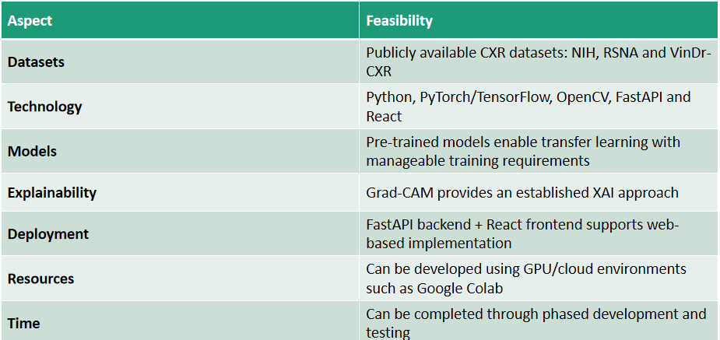

Dataset and Approach Content:
Datasets:
- NIH ChestX-ray14
- RSNA Pneumonia Detection Challenge
- VinDr-CXR

Approach:

